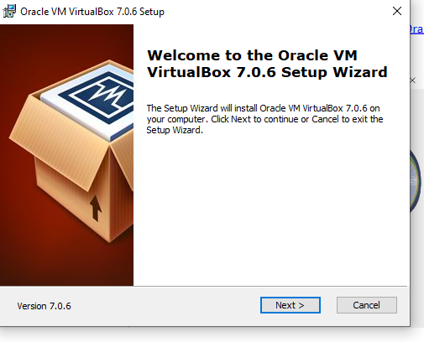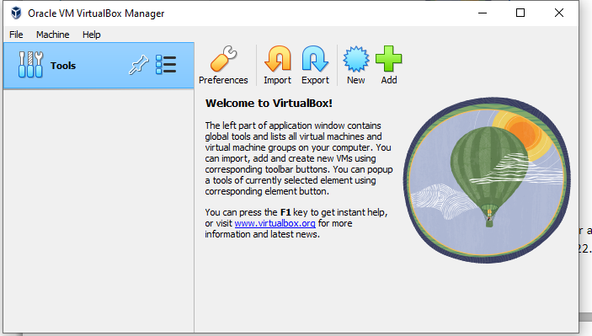

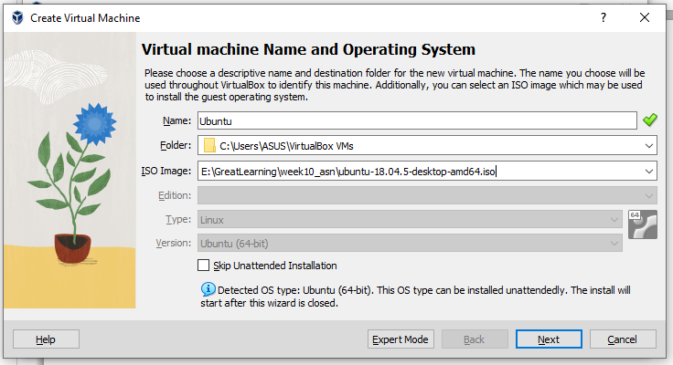

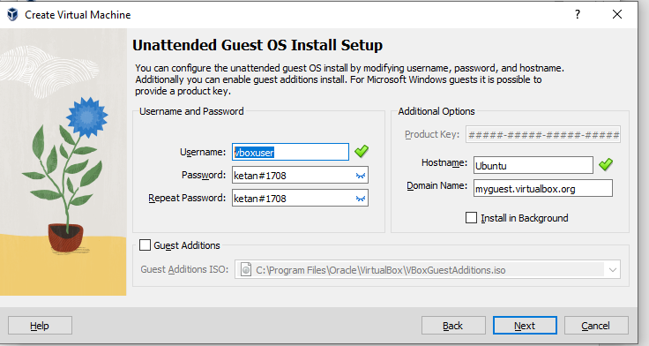

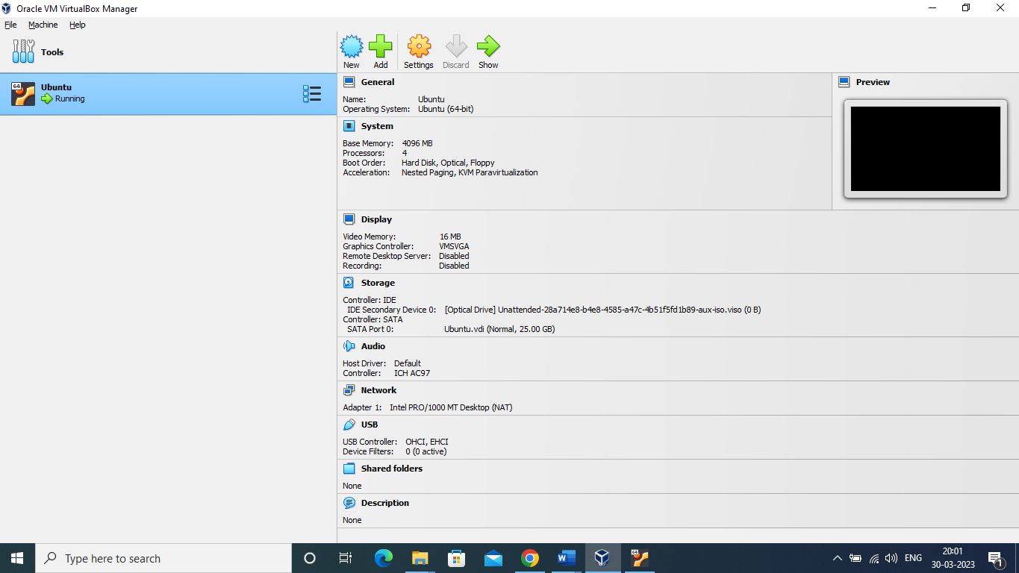

E:\GreatLearning\week10_asn\ubuntu-18.04.5-desktop-amd64

E:\GreatLearning\week10_asn\ubuntu-22.04.1-desktop-amd64.iso

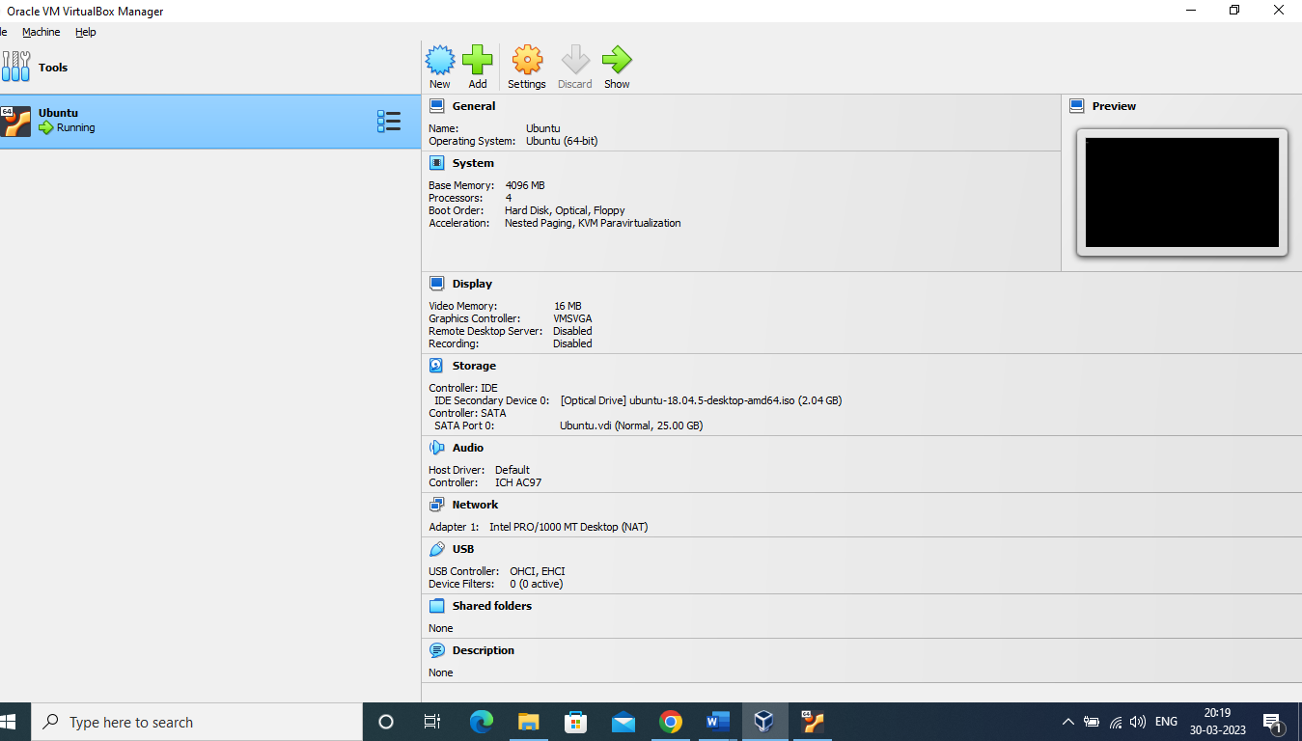

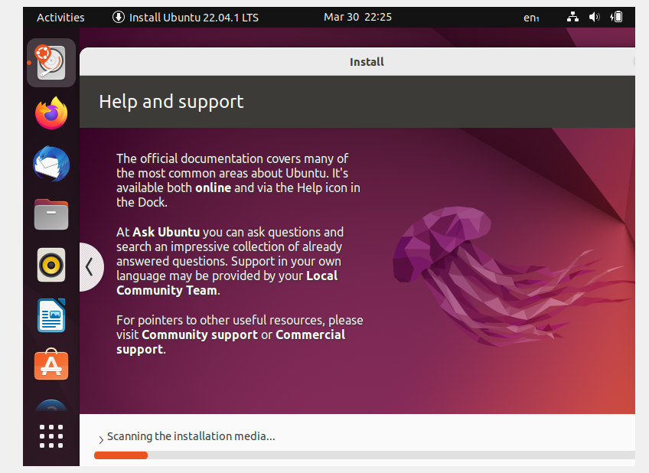

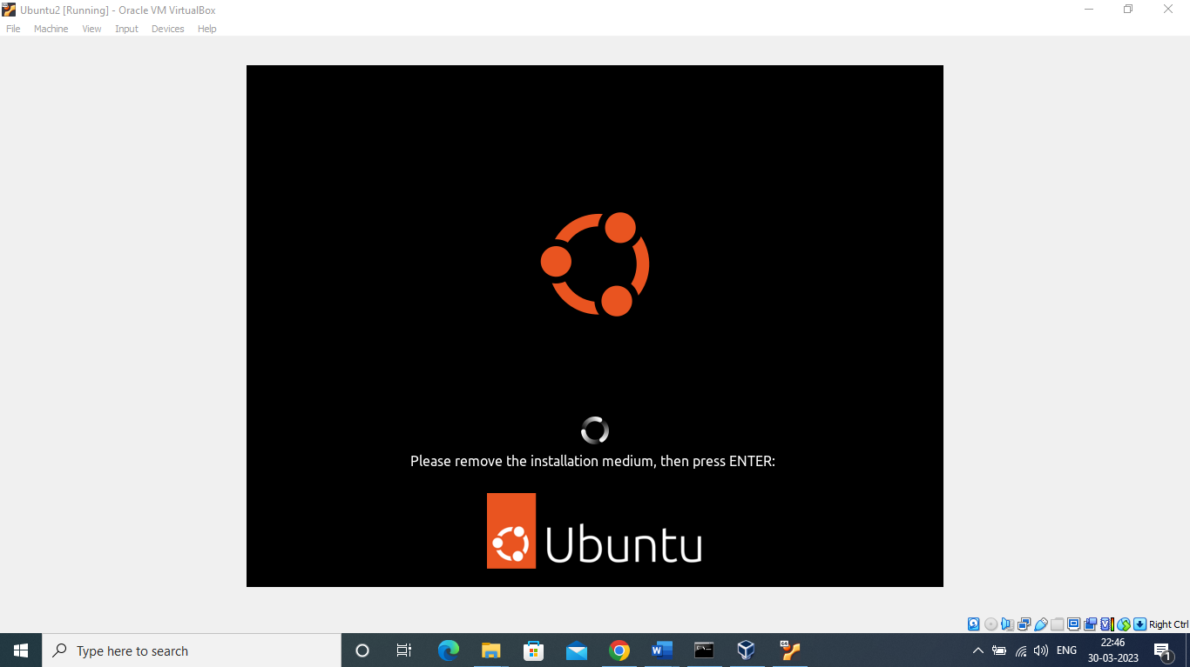

2. VS code installed:

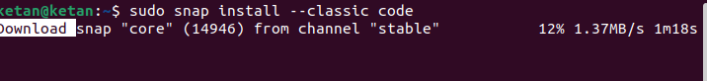

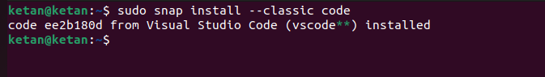

3. Python installed:

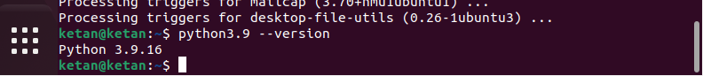

4. Clone git repository:

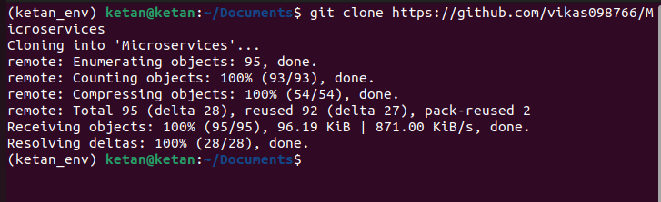

5.venv installed and virtual env created:  
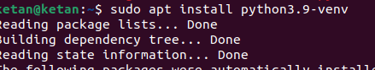



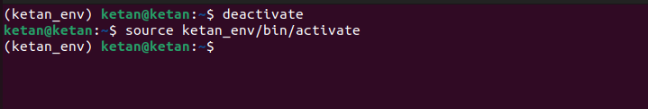

6.Install the dependencies from requirements.txt file.



7.Train and save the model.

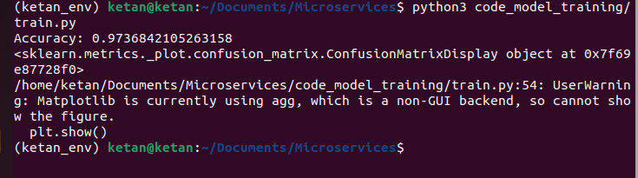

8.Test the Flask web application.

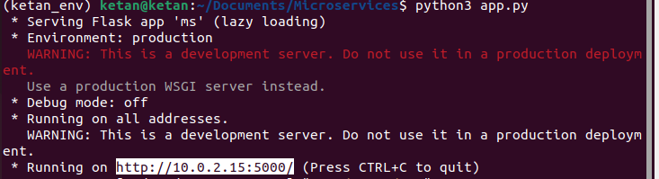

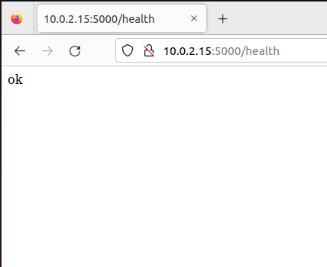

9.Test the application and make predictions using the example calls available in the folder/tests.

